**IT252 Assignment 4**

NAME: SUYASH SATISH CHINTAWAR

ROLL NO.: 191IT109

TOPIC: SQL QUERIES

**OUTPUT SCREENSHOTS**

QUESTION 1(B):

1. Compute the average price of all products with manufacturer code equal to 2.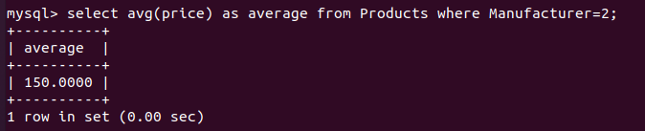

2. Compute the number of products with a price larger than or equal to $180.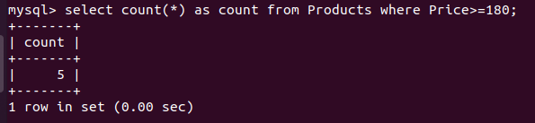

3. Select the name and price of all products with a price larger than or equal to $180, and sort first by price (in descending order), and then by name (in ascending order).

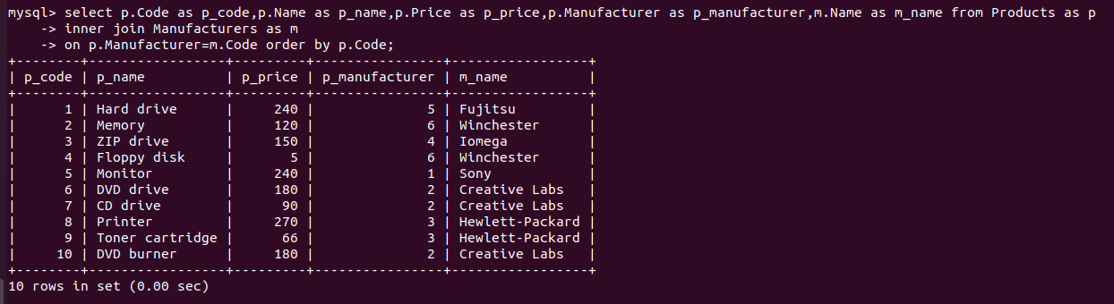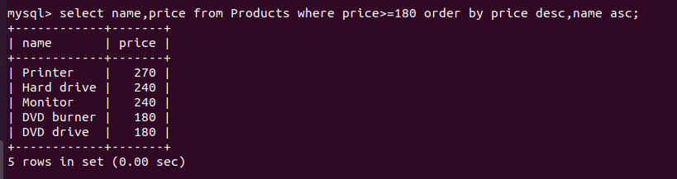4. Select all the data from the products, including all the data for each product's manufacturer.

5. Select the average price of each manufacturer's products, showing only the manufacturer's code.

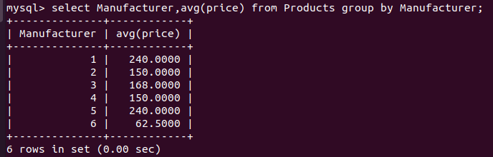

6. Select the product name, price, and manufacturer name of all the products.

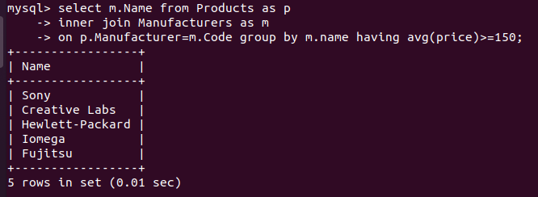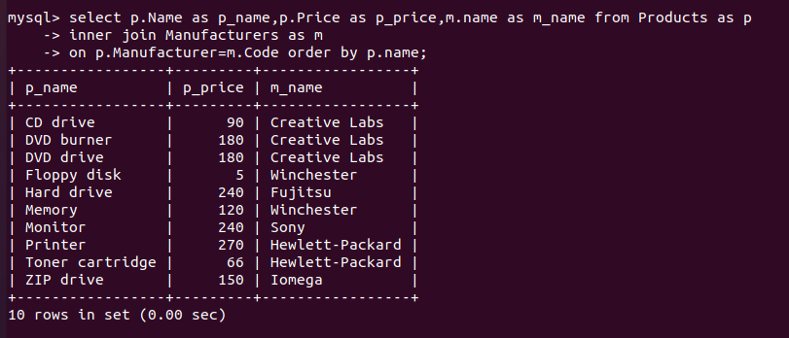7. Select the names of manufacturer whose products have an average price larger than or equal to $150.

8. Select the name and price of the cheapest product.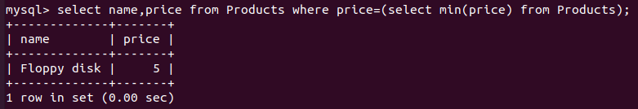

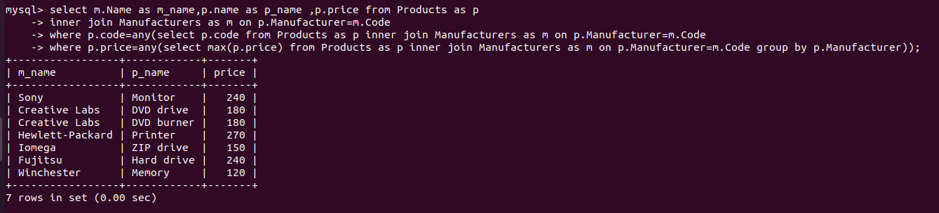9. Select the name of each manufacturer along with the name and price of its most expensive product.

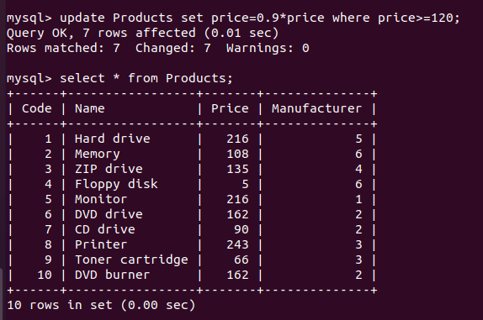10. Apply a 10% discount to all products with a price larger than or equal to $120.

QUESTION 2(B):

1.Select the number of employees in each department (you only need to show the department code and the number of employees).

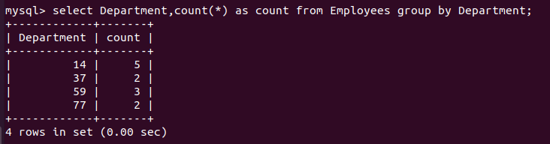

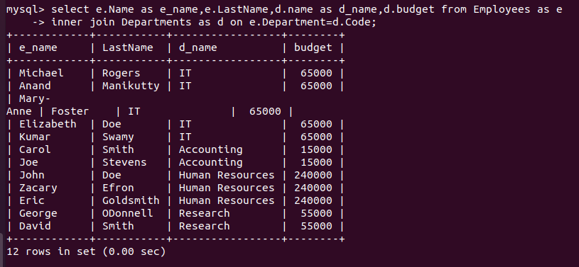2. Select the name and last name of each employee, along with the name and budget of the employee's department.

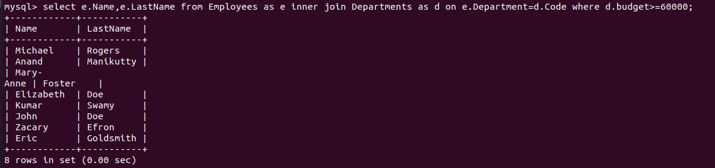3. Select the name and last name of employees working for departments with a budget greater than $60,000

4. Select the departments with a budget larger than the average budget of all the departments

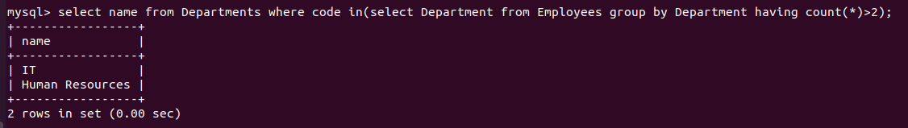5. Select the names of departments with more than two employees.

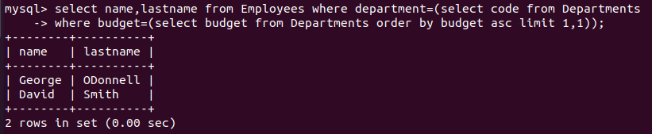6. Select the name and last name of employees working for departments with second lowest budget

7. Reduce the budget of all departments by 10%

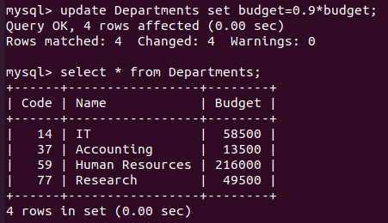

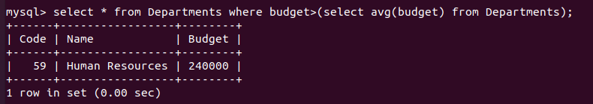

8. Reassign all employees from the Research department (code 77) to the IT department (code 14).

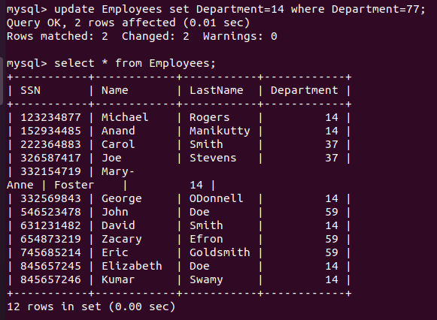

9. Add a new department called "Quality Assurance", with a budget of $40,000 and departmental code 11. And Add an employee called "Mary Moore" in that department, with SSN 847-21-9811.

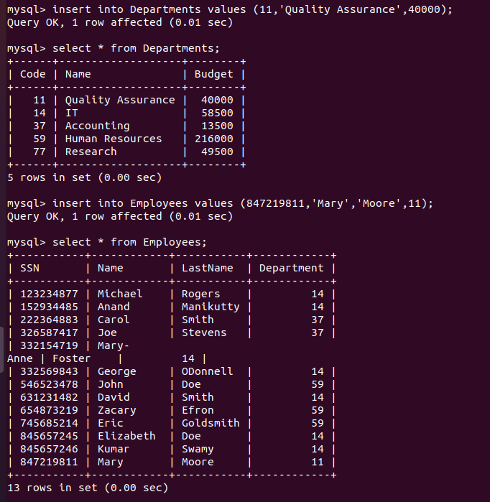

10. Delete from the table all employees who work in departments with a budget greater than or equal to $60,000.

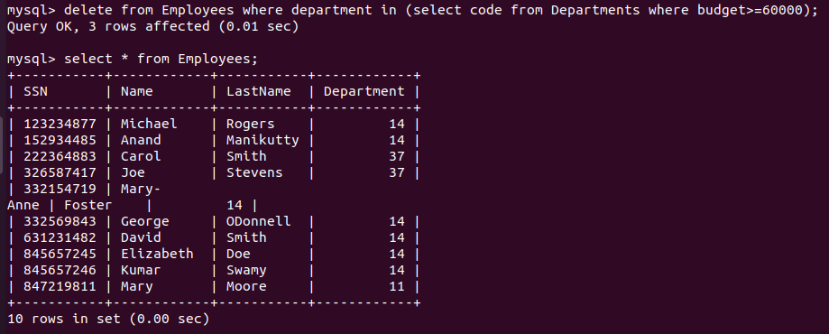**NOTE:** Log file has not been attached as permission for zip file wasn’t given.